Q Exchange Report – February 2022

‘Community Hospitals: Embedding Covid-19 positive impact changes through shared learning’

Project Overview /Abstract
There is a lack of awareness and understanding of the role that Community Hospitals (CHs) play in the UK health and care systems, including their response to COVID-19. This is partly because there is a lack of mechanisms to capture and share this learning across CHs, with CHs often fragmented by NHS and independent providers and geography.

The Community Hospital Association (CHA) was successful in its application in October 2020, to the Health Foundation Q Exchange for project funding to capture the contribution of community hospitals during COVID-19 from the staff themselves.

At the outset, the project group were committed to using quality improvement methodology. With the support of our Q Exchange Connector, we developed a theory of change model, stakeholder mapping, and a detailed evaluation plan with metrics which reflected the project’s objectives to:
- Identify, capture and share the learning and best practice in response to COVID-19;
- Enhance and develop mechanisms to share good practice across community hospitals;
- Improve awareness and understanding of the role and contribution CH’s made in response to COVID-19;
- Grow CHA members, network and reputation (and Q community).

Impact/Project Journey
In February 2021, a project group of CHA Committee volunteer members was set up to lead this work. We were aware that this could be a significant piece of work, which would be conducted in the context of the ongoing pandemic and therefore connecting with community hospitals would need be virtual. This was noted to be a significant risk, with concerns about whether staff and organisations would have the time or want to engage in the project. Key project interventions included:

- The project structure, lessons learnt log and risk register which have all been helpful, providing a clear governance and learning framework with reporting and budgetary expenditure to the CHA Directors and Committee and the Q Exchange; as well as independent feedback from a project Advisory Group.

- Data collection and analysis work: Despite initially acknowledging that a lack of engagement could be a significant risk, the data collection exceeded the project group’s expectations in terms of the depth and breadth of information gathered. Contextually there are approximately 500 CHs and 117 providers of CHs across the UK, so positively the project has connected with 33% of CHs. The enthusiasm of community hospital staff and their organisations to participate has been remarkable given the service pressures, reinforcing the initial suggestion that CHs are often fragmented and do not have the opportunity to share their learning with other community hospitals.

End of November | Number of organisations | Number of CHs
30 interviews completed with 85 staff | 20 | 168
Organisations contacted that did not take part | 24

The thematic analysis of all interviews was completed in November 2021, which then led to the selection of 11 full case studies and 22 short case studies. Currently these learning materials are being drafted and agreed with the relevant organisations prior to dissemination.

- Dissemination: The project has shared regularly shared information on social media and at each organisational interview, promoting the sharing of learning and the growth of the CHA membership. This has resulted in a significant growth in social media followers, CHA website engagement and a 100% increase in newsletter subscribers (from 134 in Feb 21 to 278 now).

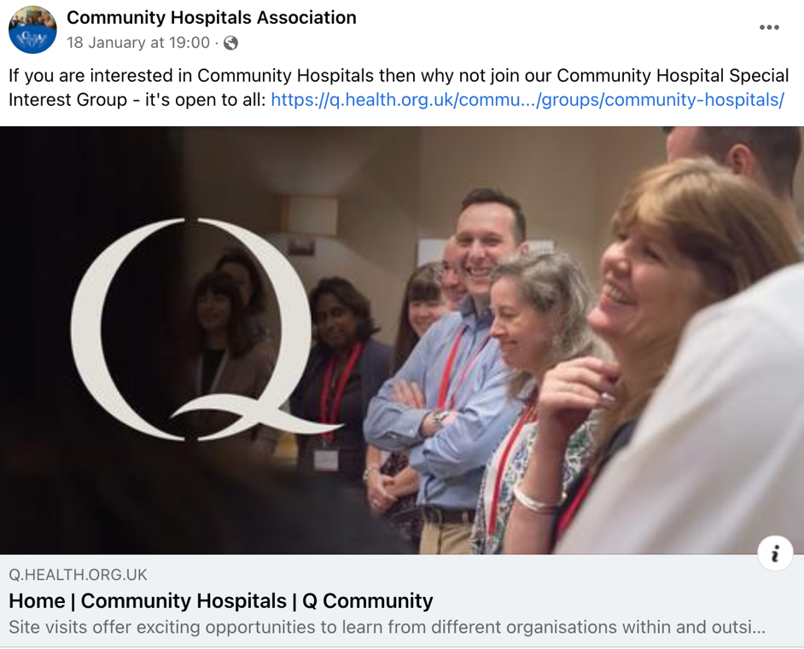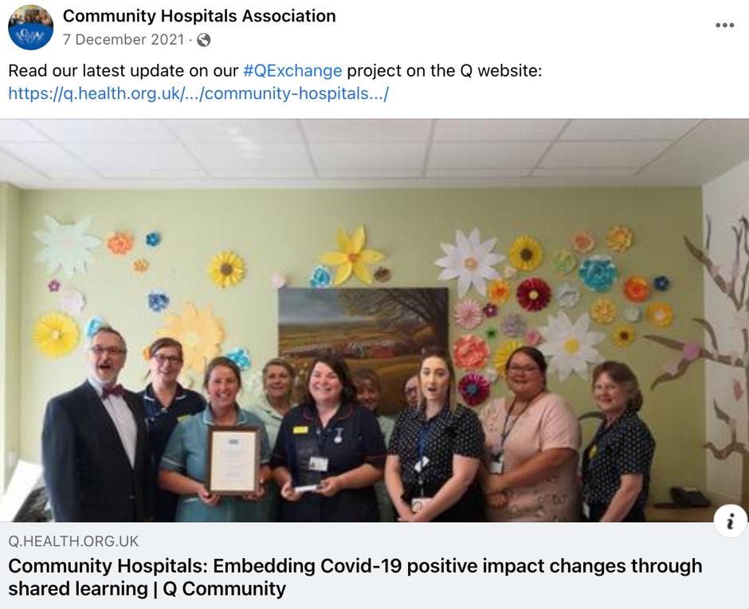

A detailed dissemination plan has been agreed to share the learning across the network of Community Hospitals and wider stakeholders. The implementation will commence in March 2022. We are delighted that a project abstract has been accepted for presentation at the International Conference of Integrated Care in Denmark in May 2022.

Learning
The early evaluation focus in the project enabled clarity on the outcomes, with regular reviews using PDSA cycles on specific interventions. The learning log has 69 specific lessons learnt which have been themed with specific examples below.
- Project Planning/process: e.g. robust project approach has ensured clarity when there is deviation from the initial plan, enabling key rationale to be documented and decisions taken.
- Project Scope: e.g. this is a quality improvement project, however this has needed to be explicit with repetitive explanation to others.
- Project Group: e.g. the expertise and commitment of project group members who are all volunteers has been key to the success of this project.
- QI iterative approach has enabled appropriate decision making e.g. not needing a survey because of good engagement from organisations in the offered interviews.
- Network, Stakeholders: The Project Advisory Group with 4 nation representatives and senior academics in tandem with the CHA existing network has enabled positive engagement in the project interviews and will also assist with the dissemination of learning.
- CH engagement/learning: there has been very positive engagement of CH staff and their provider organisations valuing the sharing of learning.
- Contracted Researcher work: it has been positive to work alongside Just Ideas (social consultancy) who are experts in their interviewing and share of learning.
- Q Support: the project has benefitted from having a Q Connector on the project group to appropriately challenge from an independent perspective as well as to educate the group further on QI methodology and its application
- Just Ideas have reflected on their learning working in partnership with the CHA, wanting to maintain the relationship and look at future collaborations.

A detailed risk log has also been maintained, with 21 identified risks with 6 remaining open. This will be helpful to review when a further project of this scale is implemented in the future by the CHA.

Communications/Sharing with the Q Community
Monthly updates on the project progress have been shared on the Q Community CH web page, and these will continue during 2022. https://q.health.org.uk/idea/2020/community-hospitals-embedding-covid-19-positive-impact-changes-through-shared-learning/

These demonstrate how the project group have reflected at each project meeting on how things are progressing, what lessons have learnt and what needed to be changed and adapted following the application of PDSA cycles. They are a dynamic reflection of the project.

The project stakeholder mapping was a key exercise which commenced in April has been built upon over the past 9 months enabling clarity on who to share the learning with and in which format. As a result of detailed consideration of the dissemination process, the Q budget was reviewed and a revised plan submitted to Q in September 2021 (approved), focussing the remaining budget resource on more dissemination activities, including graphic design.

Next steps
The project will continue to progress over the next 6 months, with an element of the project funding being used in 2022/23 for dissemination activities to:
- Complete the writing and organisational agreement of the full case studies and short case studies learning resources for dissemination
- Implement the agreed dissemination plan which includes a social media plan, targeted sharing of the learning resources, CHA/Q Special Interest Group virtual meetings, webinars, presentations to other relevant conferences and events.
- Publish and share the detailed project report

http://www.communityhospitals.org.uk/

